NAME:MANIKANTH GOUDAR

REG:192311300

COURSE: - Cryptography and Network

Security with Quantum Computing

COURSE CODE:CSA5196

1.

from Crypto.Cipher import DES

from Crypto.Util.Padding import unpad

import binascii

def generate_subkeys(key):

    """Generates 16 subkeys for DES encryption/decryption."""

    # Placeholder for actual key schedule implementation

    return [key for _ in range(16)]

def des_decrypt(ciphertext, key):

    """Decrypts a ciphertext using DES with the 16 subkeys in reverse order."""

    subkeys = generate_subkeys(key)

    reversed_subkeys = subkeys[::-1]  # Reverse for decryption

    cipher = DES.new(key, DES.MODE_ECB)

    decrypted_data = unpad(cipher.decrypt(ciphertext), DES.block_size)

    return decrypted_data

if __name__ == "__main__":

    key = b'abcdefgh'  # DES requires an 8-byte key

    ciphertext_hex = "8d20e5056a8d24d0"  # Example encrypted hex string

    ciphertext = binascii.unhexlify(ciphertext_hex)

    try:

        decrypted_text = des_decrypt(ciphertext, key)

        print("Decrypted Text:", decrypted_text.decode('utf-8'))

    except ValueError:

        print("Decryption failed: Incorrect padding or key.")

Output:

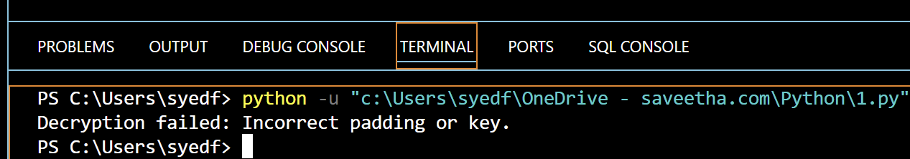

2.

from Crypto.Cipher import DES3

from Crypto.Random import get_random_bytes

from Crypto.Util.Padding import pad

import binascii

def generate_key():

    """Generate a random 24-byte key for 3DES."""

    while True:

        key = get_random_bytes(24)

        try:

            DES3.adjust_key_parity(key)

            return key

        except ValueError:

            continue

def encrypt_cbc(plaintext, key):

    """Encrypt plaintext using 3DES in CBC mode."""

    iv = get_random_bytes(8)  # 3DES requires an 8-byte IV

    cipher = DES3.new(key, DES3.MODE_CBC, iv)

    ciphertext = cipher.encrypt(pad(plaintext.encode(), DES3.block_size))

    return iv + ciphertext  # Prepend IV for decryption

if __name__ == "__main__":

    key = generate_key()

    plaintext = "Hello, World!"  # Example plaintext

    ciphertext = encrypt_cbc(plaintext, key)

    print("Encryption Key (hex):", binascii.hexlify(key).decode())

    print("Ciphertext (hex):", binascii.hexlify(ciphertext).decode())

Output:

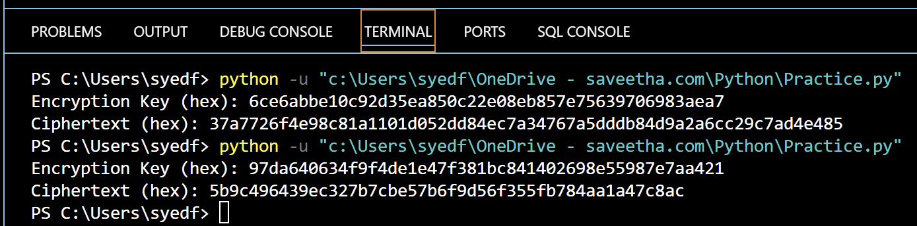

3.

from Crypto.Cipher import AES

from Crypto.Util.Padding import pad

from Crypto.Random import get_random_bytes

import binascii

def encrypt_ecb(plaintext, key):

    cipher = AES.new(key, AES.MODE_ECB)

    ciphertext = cipher.encrypt(pad(plaintext.encode(), AES.block_size))

    return ciphertext

def encrypt_cbc(plaintext, key):

    iv = get_random_bytes(AES.block_size)

    cipher = AES.new(key, AES.MODE_CBC, iv)

    ciphertext = cipher.encrypt(pad(plaintext.encode(), AES.block_size))

    return iv + ciphertext

def encrypt_cfb(plaintext, key):

    iv = get_random_bytes(AES.block_size)

    cipher = AES.new(key, AES.MODE_CFB, iv)

    ciphertext = cipher.encrypt(plaintext.encode())

    return iv + ciphertext

if __name__ == "__main__":

    key = get_random_bytes(16)  # AES requires a 16-byte key

    plaintext = "Sensitive Data for Encryption"  # Example plaintext

    ecb_ciphertext = encrypt_ecb(plaintext, key)

    cbc_ciphertext = encrypt_cbc(plaintext, key)

    cfb_ciphertext = encrypt_cfb(plaintext, key)

    print("Encryption Key (hex):", binascii.hexlify(key).decode())

    print("ECB Ciphertext (hex):", binascii.hexlify(ecb_ciphertext).decode())

    print("CBC Ciphertext (hex):", binascii.hexlify(cbc_ciphertext).decode())

    print("CFB Ciphertext (hex):", binascii.hexlify(cfb_ciphertext).decode())

Output:

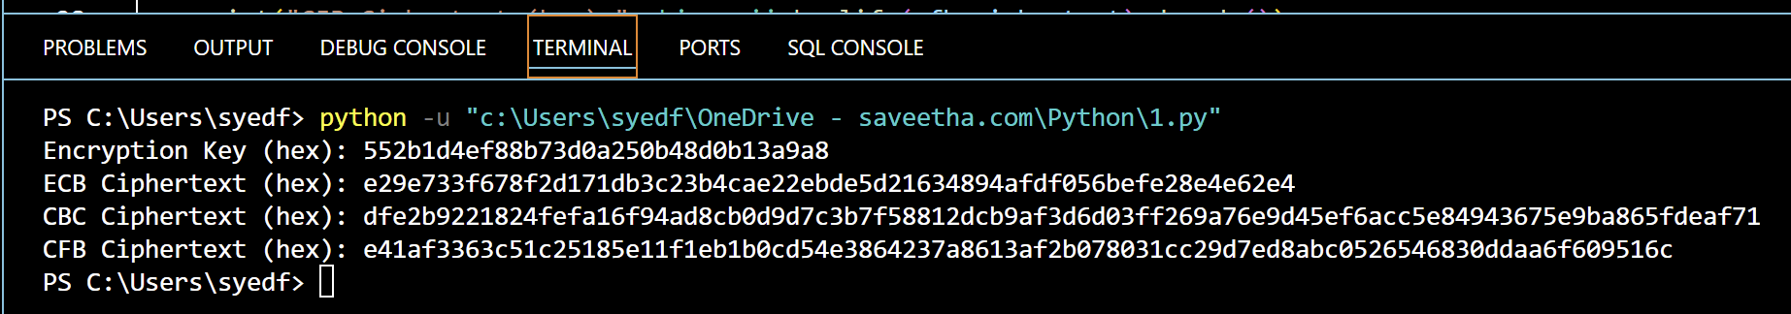

4.

from Crypto.Cipher import DES

from Crypto.Util.Padding import pad, unpad

import binascii

def binary_to_bytes(binary_str):

    return bytes(int(binary_str[i:i+8], 2) for i in range(0, len(binary_str), 8))

def encrypt_cbc(plaintext_bin, key_bin, iv_bin):

    key = binary_to_bytes(key_bin)

    iv = binary_to_bytes(iv_bin)

    plaintext = binary_to_bytes(plaintext_bin)

    cipher = DES.new(key, DES.MODE_CBC, iv)

    ciphertext = cipher.encrypt(pad(plaintext, DES.block_size))

    return ciphertext

def decrypt_cbc(ciphertext, key_bin, iv_bin):

    key = binary_to_bytes(key_bin)

    iv = binary_to_bytes(iv_bin)

    cipher = DES.new(key, DES.MODE_CBC, iv)

    decrypted_data = unpad(cipher.decrypt(ciphertext), DES.block_size)

    return decrypted_data

if __name__ == "__main__":

    key_bin = "0111111101".zfill(64)  # 10-bit key padded to 64-bit

    iv_bin = "10101010".zfill(64)  # 8-bit IV padded to 64-bit

    plaintext_bin = "0000000100100011".zfill(64)  # 16-bit plaintext padded to 64-bit

    ciphertext = encrypt_cbc(plaintext_bin, key_bin, iv_bin)

    decrypted_text = decrypt_cbc(ciphertext, key_bin, iv_bin)

    print("Ciphertext (hex):", binascii.hexlify(ciphertext).decode())

    print("Decrypted Text (binary):", ''.join(format(byte, '08b') for byte in decrypted_text))

Output:

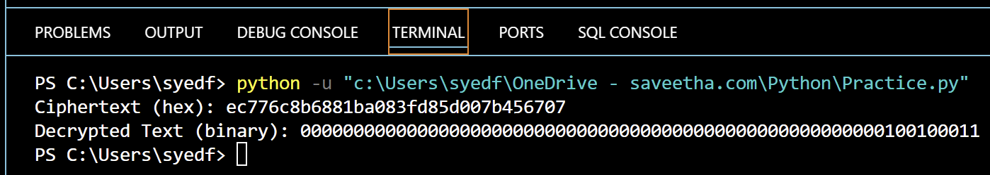

5.

import math

def gcd_extended(a, b):

    """Extended Euclidean Algorithm to find modular inverse"""

    if a == 0:

        return b, 0, 1

    gcd, x1, y1 = gcd_extended(b % a, a)

    x = y1 - (b // a) * x1

    y = x1

    return gcd, x, y

# Given public key parameters

e = 31

n = 3599

# Step 1: Find p and q through trial-and-error (factorizing n)

def find_prime_factors(n):

    for i in range(2, int(math.sqrt(n)) + 1):

        if n % i == 0:

            return i, n // i

    return None, None

p, q = find_prime_factors(n)

if not p or not q:

    raise ValueError("Failed to factorize n")

# Step 2: Compute Euler's Totient function phi(n)

phi_n = (p - 1) * (q - 1)

# Step 3: Compute private key d (modular inverse of e mod phi(n))

_, d, _ = gcd_extended(e, phi_n)

# Ensure d is positive

d = d % phi_n

print(f"Public Key (e, n): ({e}, {n})")

print(f"Prime factors: p = {p}, q = {q}")

print(f"Euler's Totient (φ(n)): {phi_n}")

print(f"Private Key (d, n): ({d}, {n})")

Output:

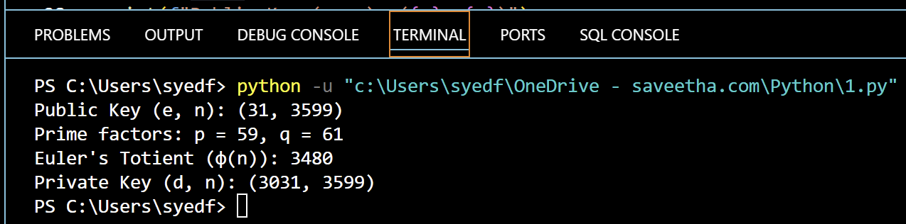

6.

import random

def diffie_hellman(p, g, secret_a, secret_b):

    # Compute public values

    A = pow(g, secret_a, p)

    B = pow(g, secret_b, p)

    # Compute shared secret key

    shared_key_a = pow(B, secret_a, p)

    shared_key_b = pow(A, secret_b, p)

    return A, B, shared_key_a, shared_key_b

# Public parameters

p = 23  # Prime number

g = 5   # Generator

# Alice and Bob choose secret numbers

secret_a = random.randint(1, p-1)

secret_b = random.randint(1, p-1)

# Perform Diffie-Hellman key exchange

A, B, shared_key_a, shared_key_b = diffie_hellman(p, g, secret_a, secret_b)

print(f"Public Parameters: p={p}, g={g}")

print(f"Alice's Secret: {secret_a}")

print(f"Bob's Secret: {secret_b}")

print(f"Alice Sends: {A}")

print(f"Bob Sends: {B}")

print(f"Alice Computes Shared Key: {shared_key_a}")

print(f"Bob Computes Shared Key: {shared_key_b}")

assert shared_key_a == shared_key_b, "Shared keys do not match!"

Output:

